**Preferred Orgs and Fundraisers – Know How**

**What is this?**

Preferred Orgs and Fundraisers = Participating nonprofits, Fundraisers/Project pages.

For giving days, we create a branded giving site. This branded giving site needs to be supplied with a list of participating nonprofits, individual FR’s/Project pages. Only these nonprofits, FR’s and Projects must show up on the search page (with the branded site causes only checkbox checked).

**How to feed the list of preferred orgs and FR/Project pages to the branded giving site?**

The preferred list can be uploaded through the admin page. It is a .csv file that can contain EIN’s/URN’s of Orgs, URN’s of individual FR/Project pages.

To upload the preferred list: Go to Admin->Brand Edit->Preferred Causes tab

Select the .csv file with the preferred list and “Save Changes”.

**What cannot be a part of the Preferred List?**

We cannot have any the teams as a part of the preferred list. If by mistake, a team URN is used in the list on uploading the user will get an error message that the URN is not valid.

We cannot mention NCES id of schools. If schools need to be a part of the list, their URN’s should be used.

**If an Org is part of the list, what does it pull in?**

To add an Org to the list, we can use either the EIN or URN

If an Org is a part of the list, all associated Fundraiser and Project pages (if they exist) of the Org will be pulled in and they show up on the search results. Donations can be made directly to the Org or to any its associated FR/Project pages that show up on the search results.

**If an individual FR is a part of the list, what does it pull in?**

To add an FR/Project page to the list, we should use its URN

It does not pull anything. Only individual FR will be listed on the search results. We discard all associated FR’s /Projects and the nonprofit the FR belongs to.

**Can an Org and FR/Project page have the same URN’s?**

No. It is not possible to have the same URN for an Org and FR/Project page.

**Preferred Orgs and FR/Project pages – Preliminary Testing**

Once a preferred list is uploaded to the branded giving site, check for the following:

1. Go to the Search page and make sure if “<Branded Giving Site> Causes Only” checkbox appears on the top right corner and is checked.
2. If an org was part of the preferred list, make sure the org itself and all its associated FR’s/Project pages are listed on the search results.
3. If a FR/Project page was a part of the preferred list, only that page should be present. The associated Org/Fr/Pro pages should not be listed on the search results.

**How giving day totals are computed?**

To explain how totals are calculated, let us take a sample CMS page with a leaderboard of the preferred list and the giving day totals displayed at the top of the page.

**Known Issues:**

1. The cache period for the giving day total counters and the leaderboard totals are different. For example, latest donation takes max 5 mins to get updated at the top grand total whereas it takes max 15 to get updated in the leaderboard section. So right now, the giving day totals and leaderboard totals are not in sync.
2. Giving Day Total Counters are brand specific whereas leaderboard totals are not brand specific. This means that the totals on the leaderboard will not match the giving day totals counter sometimes. Reason being if a donation is made on another site for the FR that is part of the leaderboard, that count gets pulled into the leaderboard though it shouldn’t be counted towards to giving day.

We will go through 7 basic happy path scenarios on how these totals are computed:

**Pre-Condition:**

For each donation, login in as a new user so that the donor’s counts increment by 1 every time a donation is made.

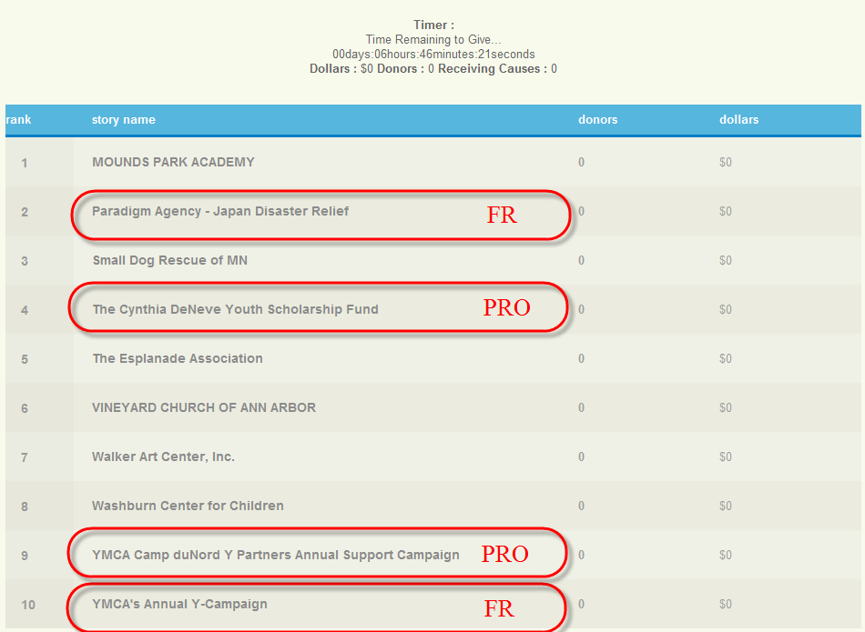

The above leaderboard contains a combination of Org’s, FR and Project pages. The one’s that are FR/Project are highlighted.

The total counters on the top display total dollars raised, total donors and Total number of receiving nonprofits.

**Scenario 1:**

**Donation made to FR (part of the preferred list)**

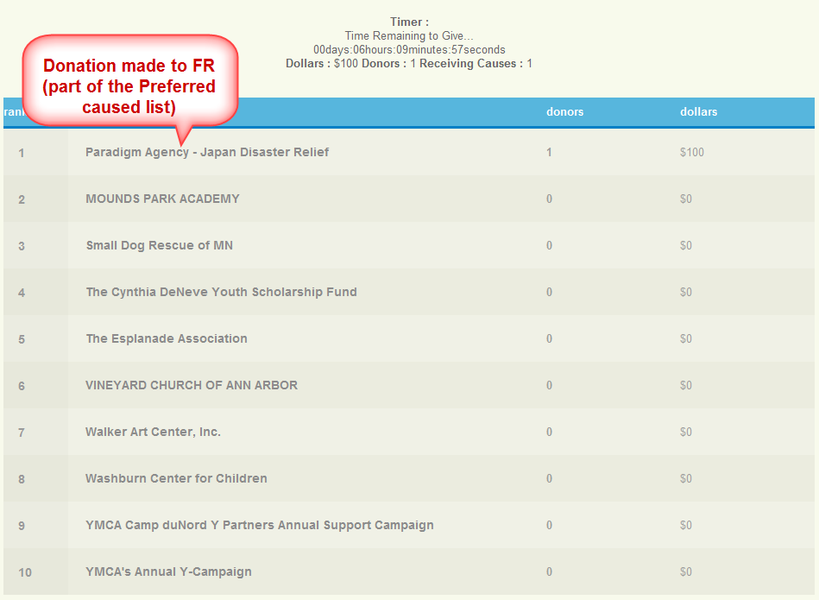

A first donation of $100 is made to the FR “Paradign Agency – Japan Disaster Relief”. The total on the leaderboard is updated.

The totals counter on the total is updated

Dollars: $100

Donors: 1

Receiving Causes: 1

Scenario 2:

**Donation made to Project (part of the preferred list)**

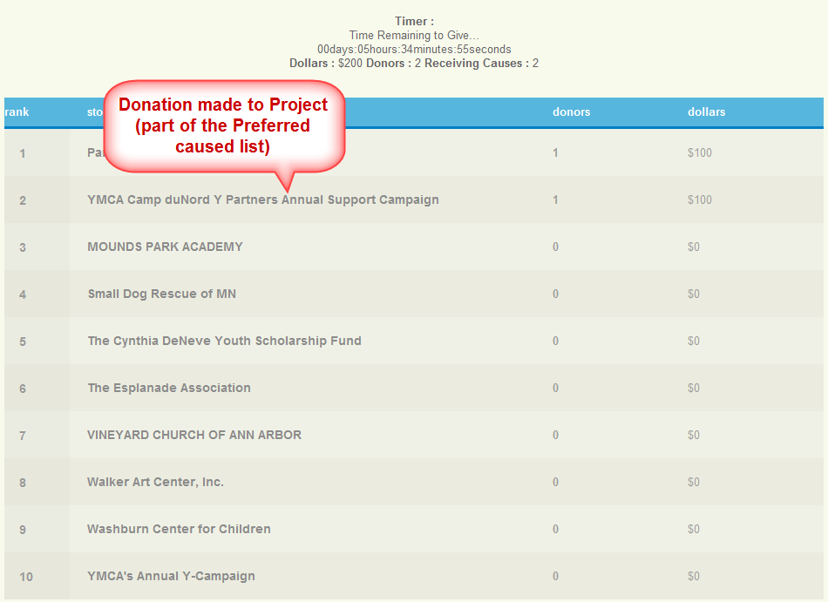

A second donation of $100 is made to the Project “YMCA Camp ...”. The total on the leaderboard is updated.

The totals counter on the total is updated

Dollars: $200

Donors: 2

Receiving Causes: 2

**Scenario 3:**

**Donation made to Org (which is in the preferred list )**

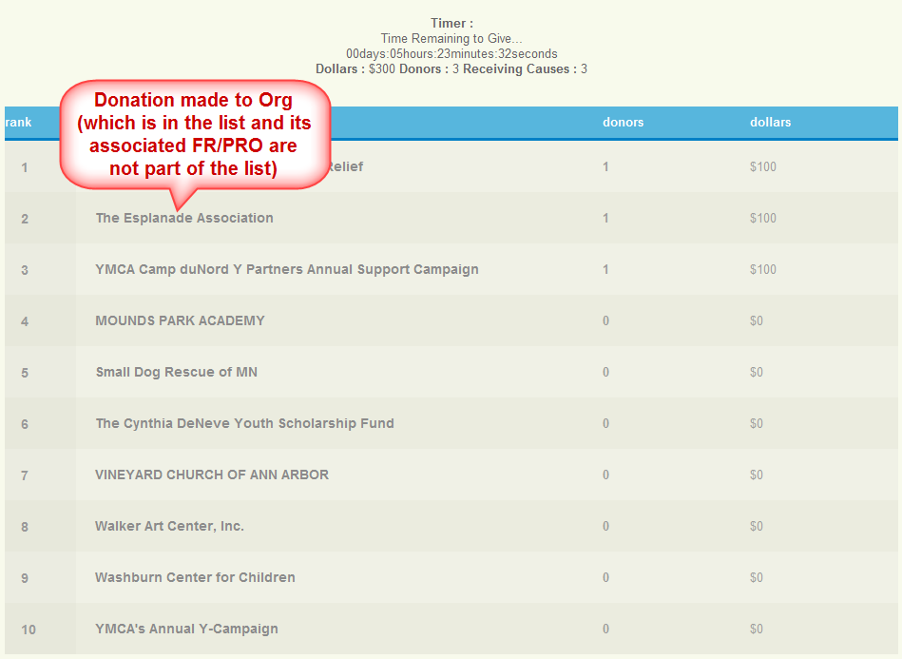

A third donation of $100 is made to the Org directly “The Esplanade Association”. The total on the leaderboard is updated.

The totals counter on the total is updated

Dollars: $300

Donors: 3

Receiving Causes: 3

Scenario 4:

**Donation made to FR (not in the preferred list but its Org is present in the list)**

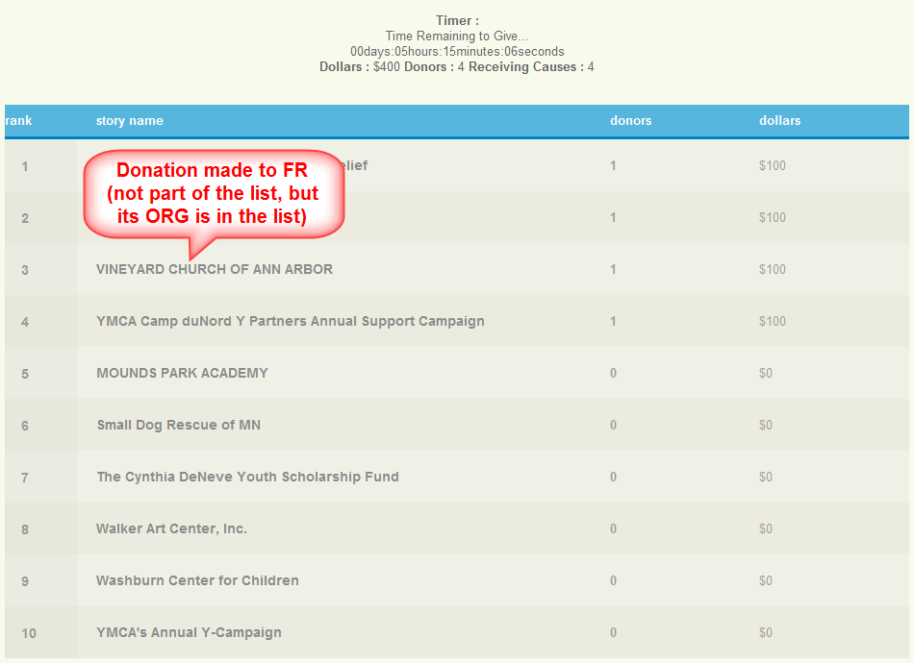

A fourth donation of $100 is made to one of the FR’s of a Org (Vineyard Church of Ann Arbor) which is a part of the preferred list. The total on the leaderboard is updated.

The totals counter on the total is updated

Dollars: $400

Donors: 4

Receiving Causes: 4

**Scenario 5:**

**Donation made to Project (not in the preferred list but its Org is present in the list)**

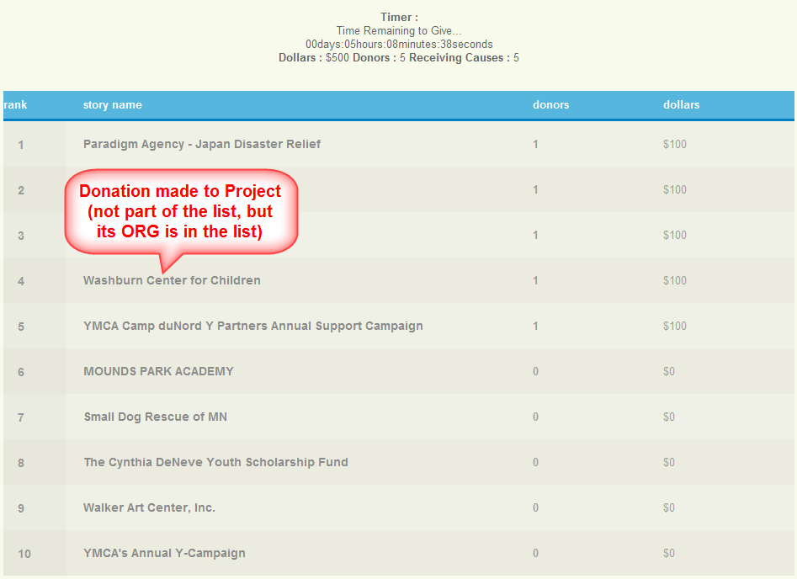

A fourth donation of $100 is made to one of the Project page of an Org (Washburn Center for Children) which is a part of the preferred list. The total on the leaderboard is updated.

The totals counter on the total is updated

Dollars: $500

Donors: 5

Receiving Causes: 5

Scenario 6:

**Donation made to ORG (part of the preferred list) and the user already made donation to the associated Project page**

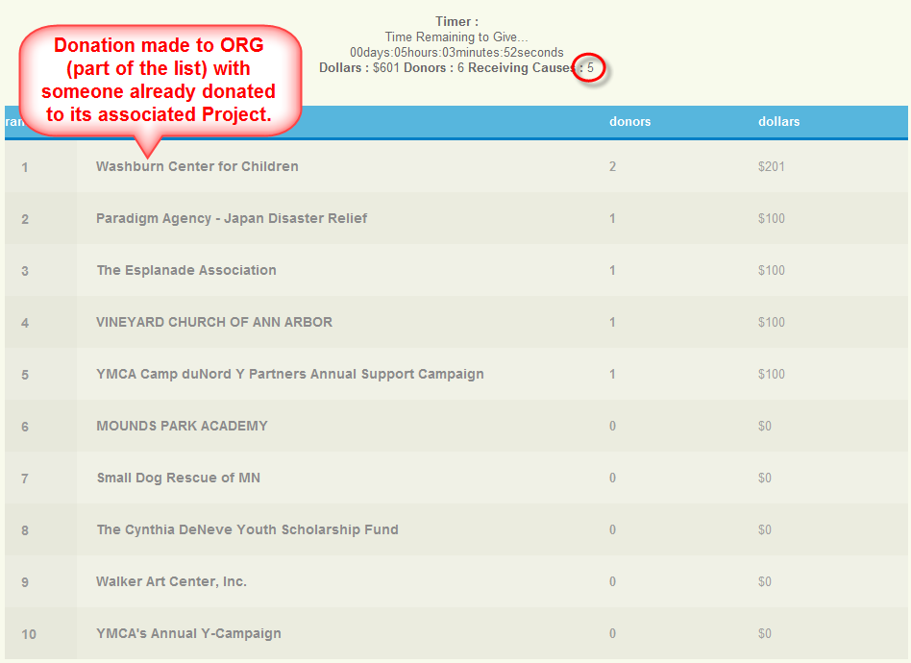

A fifth donation of $100.50 is made to an Org (Washburn Center for Children) which is a part of the preferred list. The total on the leaderboard is updated.

The totals counter on the total is updated

Dollars: $ 601

Donors: 6

Receiving Causes: 5 **(Remains the same) – The reason being a donation was already made to this Org’s Project page.**

Scenario 7:

**Refund the recent donation made in Scenario 6 ($100.50)**

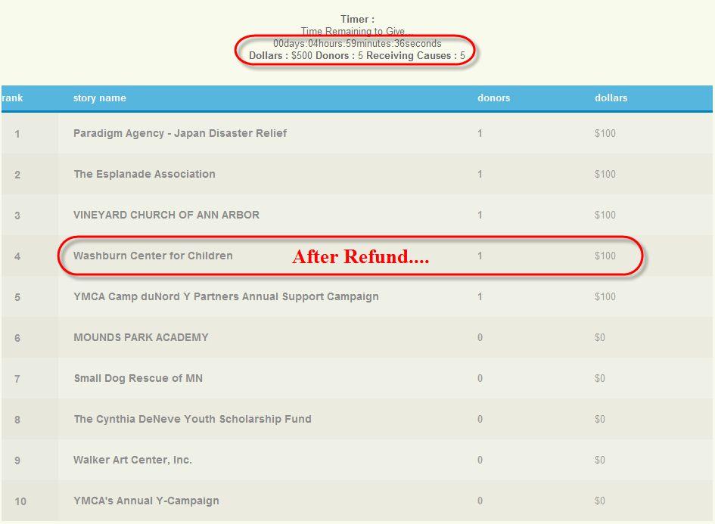

Refunding the previous donation made to Washburn Center for Children

After refunding, the counters and the leaderboard totals get updated

Leaderboard Total for Washburn Center for Children: $ 100 (After Refund)

Totals Counters:

Dollars: $500 **(Changes since the donation was refunded)**

Donors: 5 **(Changes since the donation was refunded)**

Receiving Causes: 5 **(No change)**

**Test Scenarios for Preferred Orgs and Fundraiser (Positive and Negative Edge Cases)**

1. Upload preferred NPOs list with invalid URNs
2. Don’t upload preferred NPOs list and verify CMS page
3. Upload preferred NPOs list without URNs
4. Upload preferred NPOs list with valid URNs
5. Upload preferred NPOs list with valid EINs
6. Upload preferred NPOs list with valid NCES. It should not accept and should throw error message
7. Upload preferred NPOs list with valid school URN.
8. Upload preferred NPOs list with valid Team URNs
9. Upload preferred NPOs list with valid school FR/PRO URNs.
10. Upload preferred NPOs list with valid ORG URNs, different FR, PRO URNs
11. Upload preferred NPOs list with valid ORG URNs and its FR, PRO URNs
12. Upload preferred NPOs list with existing URNs
13. Upload preferred NPOs list with new URNs and verify Error message
14. Upload preferred NPOs list with valid URN and duplicate URN's
15. Upload preferred NPOs list with valid EIN and duplicate EIN
16. Upload preferred NPOs list with valid NCES and duplicate NCES
17. Upload preferred NPOs list with unverified ORG URNs
18. Upload preferred NPOs list unverified ORGs FR/PRO URNs
19. Upload preferred NPOs list blacklisted ORG URNs
20. Upload preferred NPOs list blacklisted ORGs FR/PRO URNs
21. Upload preferred NPOs list with valid ORG URNs and donation made
22. Upload preferred NPOs list with valid ORG URNs and donation made and refunded
23. Upload preferred NPOs list with valid FR URNs
24. Upload preferred NPOs list with valid FR URNs and make donations and check
25. Upload preferred NPOs list with valid FR URNs and make donations, refund and check
26. Upload preferred NPOs list with valid PRO URNs
27. Upload preferred NPOs list with valid PRO URNs and make donations and check
28. Upload preferred NPOs list with valid PRO URNs and make donations, refund and check
29. Upload preferred NPOs list with valid ORG URNs
30. Upload preferred NPOs list with valid ORG URNs and make donations to ORG and to its FR, PRO and check
31. Upload preferred NPOs list with valid ORG URNs and make donations to ORG and to its FR, PRO, refund and check
32. Upload preferred NPOs list with valid ORG, different FR, PRO URNs
33. Upload preferred NPOs list with valid ORG, different FR, PRO URNs and make donations to ORG and to its FR, PRO, different FR, PRO URNs and check
34. Upload preferred NPOs list with valid ORG URNs, different FR, PRO URNs and make donations to ORG and to its FR, PRO, different FR, PRO URNs, refund and check
35. Upload preferred NPOs list with valid ORG, different FR, PRO URNs and make donations through donation widget to ORG and to its FR, PRO, different FR, PRO URNs and check
36. Upload preferred NPOs list with valid ORG, different FR, PRO URNs and make donations through donation widget to ORG and to its FR, PRO, different FR, PRO URNs, refunded and check
37. Upload preferred NPOs list with valid ORG, different FR, PRO URNs and make donations through Giving Card to ORG and to its FR, PRO, different FR, PRO URNs and check
38. Upload preferred NPOs list with valid ORG, different FR, PRO URNs and make donations through Giving Card to ORG and to its FR, PRO, different FR, PRO URNs, refunded and check
39. Upload preferred NPOs list with valid ORG, different FR, PRO URNs and make donations through Offline to ORG and to its FR, PRO, different FR, PRO URNs and check((Should not be included)
40. Upload preferred NPOs list with valid ORG, different FR, PRO URNs and make donations through Offline to ORG and to its FR, PRO, different FR, PRO URNs, refunded and check(Should not be included)
41. Upload preferred NPOs list with valid ORG, different FR, PRO URNs and make donations through recurring donation to ORG and to its FR, PRO, different FR, PRO URNs and check
42. Upload preferred NPOs list with valid ORG, different FR, PRO URNs and make donations through recurring donation to ORG and to its FR, PRO, different FR, PRO URNs, refunded and check
43. Upload preferred NPOs list with valid ORG, different FR, PRO URNs and make donations through schedule donation to ORG and to its FR, PRO, different FR, PRO URNs and check
44. Upload preferred NPOs list with valid ORG, different FR, PRO URNs and make donations through schedule donation to ORG and to its FR, PRO, different FR, PRO URNs, refunded and check